

**Safeguarding Team**

Mr M Snook

Designated Safeguarding Lead

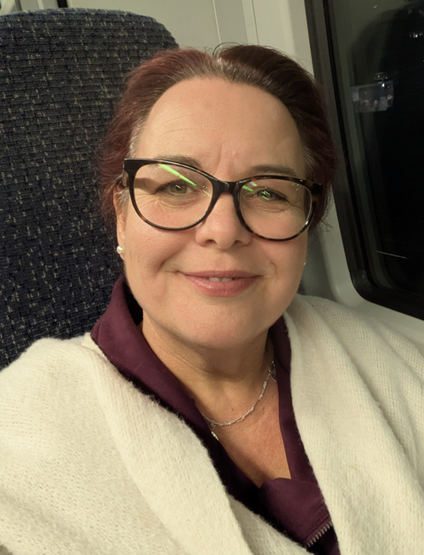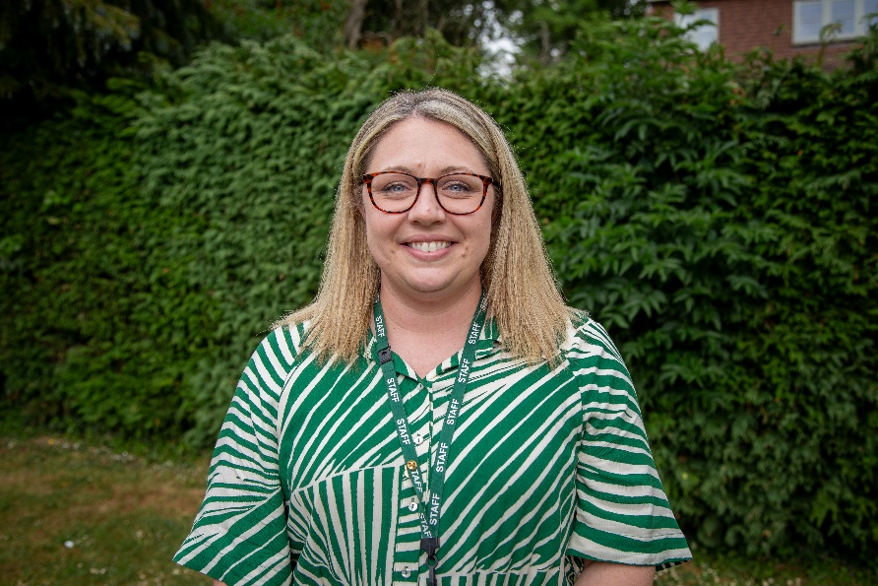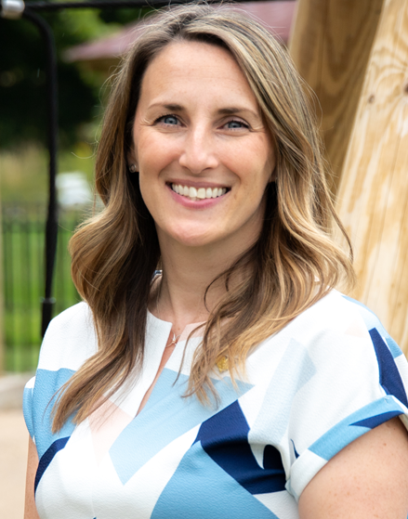

Mr Adam McIntosh

Governor

Safeguarding Lead

Mrs L Wright

Director of Primary

Deputy Designated Safeguarding Lead

Mrs K Wickens

Deputy Designated

Safeguarding Lead

Miss C Jones

Deputy Designated Safeguarding Lead

**Child protection Contacts**

|  |  |  |
| --- | --- | --- |
| If you have a concern about a child contact the  **Integrated Front Door** | If you have a concern around a staff member talk to the Head Teacher.  If you have a concern about the Head Teacher contact the  **LADO Consultation Contact** | For advice contact the  **Safeguarding In Education Team** |
| 01403 229900  <https://www.westsussex.gov.uk/education-children-and-families/keeping-children-safe/request-support-or-raise-a-concern-about-a-child/> | 0330 2226450 | 0330 2224030  [Safeguarding.education@westsussex.gov.uk](mailto:Safeguarding.education@westsussex.gov.uk) |
|  |  |  |